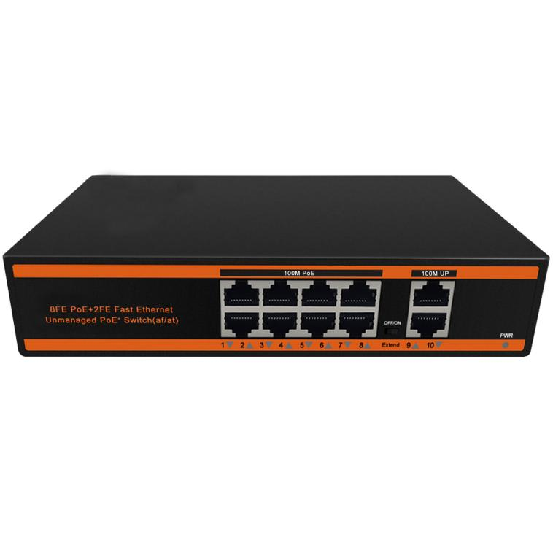
FEATURES
- 8*10/100Mbps PoE ports, 2*10/100Mbps uplink port
- Support IEEE802.3af/at
- Support restrain network storm, VLAN function
- Support Max Transmission distance up to 250m
- All port supported by MDI/MDIX auto flip and self-negotiation
- Built-in power supply
- Maximum power of single PoE port: 30 W
- Whole machine power: 120W&150W
- Adopts store-and-forward architecture
- Fanless, natural cooling, small,compact and quiet design, suitable for desktop or wall
- Support lightning protection 4KV

Newbridge®ND-HP0820 series PoE switch is designed by NEWBRIDGE for meeting the demand of PoE power supply. It adopts the latest high-speed Ethernet switching chip and ultra-high backplane bandwidth design, with extremely fast data processing capability to improve smooth data transmission performance. It has 8 PoE-powered RJ45 ports and 2 RJ45 uplink ports. All of eight RJ45 ports support IEEE 802.3af/at standard , with a maximum power supply of 30W for a single port and 120W&150W for the whole machine, which can automatically detect and identify the powered devices that comply with IEEE 802.3af/at standard and supply power for the priority mechanism through the network cable.
With simple and convenient installation and maintenance means and rich service features, it helps users to build a safe and reliable high-performance network. It is mainly positioned at the core or convergence layer of user networks such as industrial parks, buildings, factories and mines, government agencies, and community broadband; it can be widely used in Ethernet access scenarios such as SMEs, Internet cafes, hotels, and schools.

Specifications
Power | Power Adapter Voltage |  | AC 110V-240V
 | Consumption |  | 120W/150W
Network Connector | Network Port | PoE Ethernet Port | 1～8 Port : 10/100Mbps
 |  | Ethernet port | Uplink Port : 10/100Mbps
 | Transmission Distance |  | 1～8 Port :  100Mbps:0~100m;  10Mbps: 0~250m;
 |  |  | Uplink Port : 0 ~ 100m
 | Transmission Medium |  | Cat5/5e/6 standard network cable
Network Switch | Network Standard |  | IEEE802.3/802.3u, IEEE802.3x,IEEE802.ab
 | Switching Capacity |  | 2.0Gbps
 | Packet Buffer Memory |  | 1Mbits
 | Throughput |  | 1.488Mpps
 | MAC Table |  | 1K
 | Packet Forwarding rate |  | 10Mbps:14880pps/port 100Mbps: 148800pps/port
Power Over Ethernet | PoE Standard |  | IEEE 802.3af/at
 | PoE Power Supply |  | 12 + ,36 - , 4 core power supply
 | PoE Power |  | af=15.4W,at=30W for each port
RJ45 port | Port Function |  | Power priority mechanism, fast and forward, MAC automatic learning and aging IEEE802.3X Full-duplex and mode and backpressure for Half-duplex mode
LED Indicator | LED Indicator |  | LINK/ACT.100Mbps;  PoE Status Indicator;  Power indicator;  Extender
Environmental | Working temperature |  | 0℃~55℃
 | Relative Humidity |  | 20~95%
 | Storage temperature |  | -20℃~70℃
Mechanical | Dimension (L×W×H) |  | 220mm*140mm*45mm
 | Color |  | Black
 | Weight |  | 1.05kg

Application
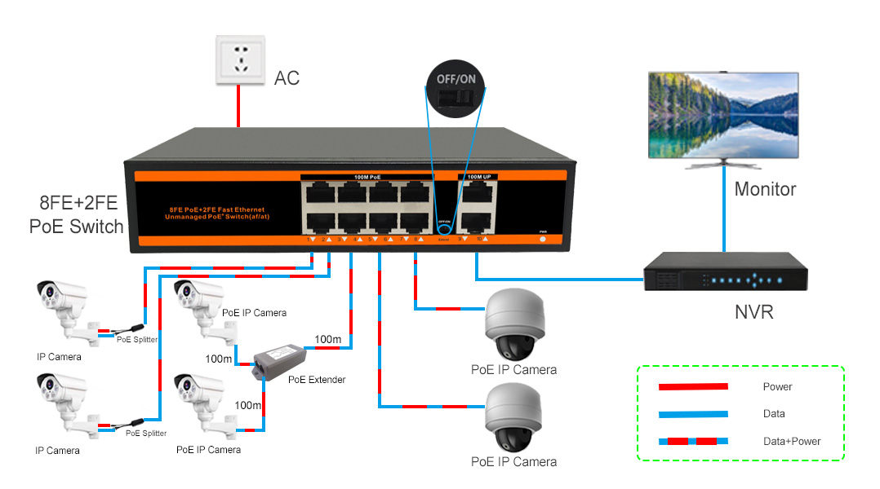

Order Information
Part No | Description of product | Unit
ND-HP0820 | 10 ports switch with 8*10/100M PoE ports,2*10/100M Uplink Port,PoE Standard: IEEE 802.3af/at,PoE data & power transmission distance 100meters(100Mbps),250meters(10Mbps),optional power supply 120W or 150W | pc

